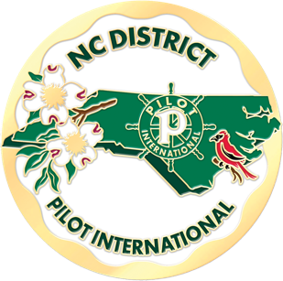
NC DISTRICT CLUB PRESIDENTS

CLUB PRESIDENT EMAIL
ASHEBORO CAROLE BULLA Dabulla5@yahoo.com
CHINA GROVE/LANDIS JANICE PARKER Jparker108@carolina.rr.com
FOOTHILLS ZANA WHITMIRE Zana1626@att.net
GREENSBORO KIMBERLY OLIVER Kholiver@hotmail.com
KANNAPOLIS AMY HURST Tarheelpilot1981@yahoo.com
LAURINBURG AMY INNISS Ainniss@roadrunner.com
LINCOLNTON MARY ANN EADDY Maryanneady@gmail.com
LUNCHEON ROCKY MOUNT SUSAN LARKINS Shlarkins@suddenlink.net
MORGANTON HANNAH DIGH Hcdigh@att.net
RALEIGH MARY JO ROSE Maryjorose@outlook.com
RUTHERFORD COUNTY DONNA MCCANN Donnam839@yahoo.com
SOTTISH LAURINBURG TERRY GALLMAN Terrygallman@gmail.com
TARBORO KATHY ROGISTER Beecy51@gmail.com
VALDESE JULIE HUFFMAN Lmbounous@gmail.com

