Consider Purchasing an AD
In the
NC District Pilot International
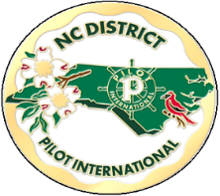
85th District Convention
Program Book

- Pilots can honor your Club or District Leaders
- Pilots can celebrate Club Activities or Anniversaries
- Pilots / Friends can advertise services or their businesses.

Deadline to Purchase an Ad is March 15, 2024.
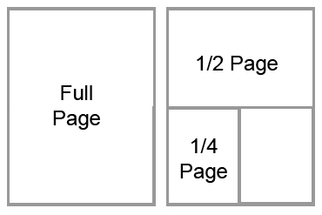
Circle the ad you are purchasing.
Full Page $100.00

½ Page $50.00

¼ Page $25.00

Pilot Club of

Contact Person _______________________ Phone #____________
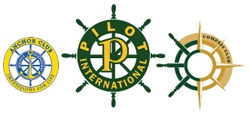
Send copy-ready ad along with payment and this form to
Frances Wright, NC District Treasurer
1404 Canterbury Rd
Tarboro, NC 27886 Make Check Payable to NC District Treasurer

