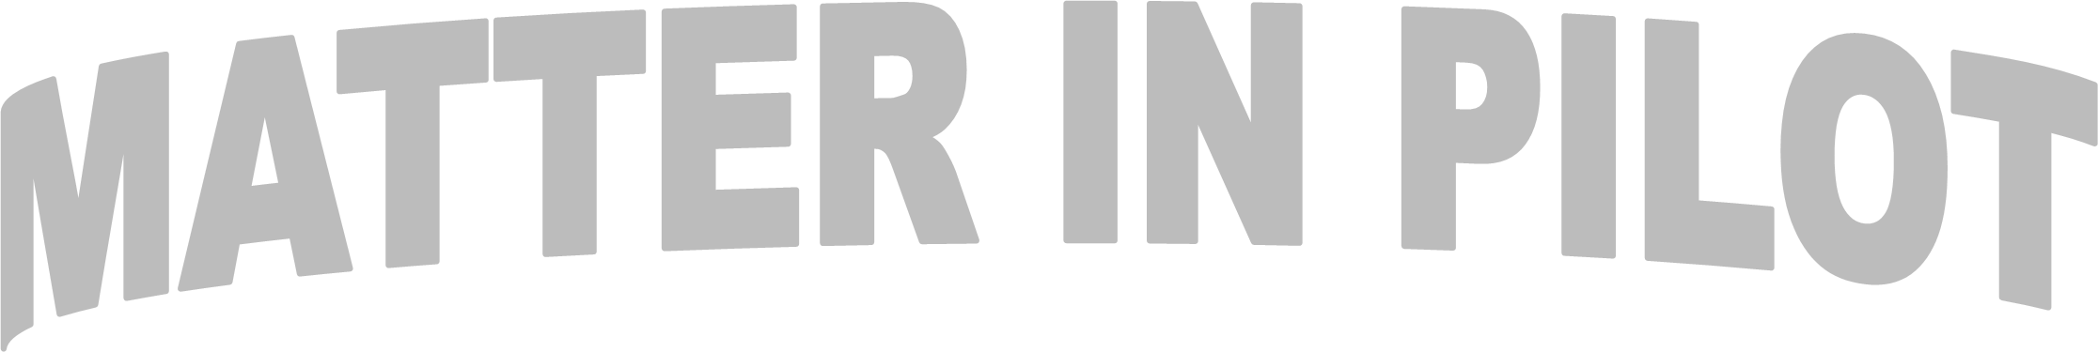
Registration Cost:

$120.00

Deadline to Register: March 8, 2024

2023
-
DISTRICT CONVENTION
2024

APRIL 5 & 6

St. James Community Center,

4136
Southport
-
Supply Rd. SE, St. James, NC 28461

Make check payable to: NC DISTRICT PILOT
NAME  (AS TO APPEAR ON NAMETAG)  Pilot Club of _______________________________ | Delegate ☑ | Nondelegate  ☑ | Past Governor ☑ | Installation  Banquet☑ | Banquet Only  ☑  $40 |  | Amt  Paid
 |  |  |  |  |  | Total
Mail Registration form with payment to:
Frances Wright, 1404 Canterbury Rd., Tarboro, NC 27886

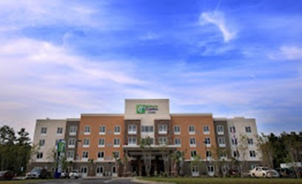
Rooms have been reserved at the Holiday Inn Express, Southport-Oak Island, 3400 Southport Supply Road, Bolivia, NC 28422 for April 5 & 6.

Rates are $109 plus tax per night for a double room. Breakfast is included. When making reservations, make sure you tell them you are with NC District Pilot.
Telephone #: 910-253-9100.

Reservations must be received by March 8. No refunds will be issued for cancellations after March 8.

